CARLA OBJECT DETECTION DATASET

CARLA Object Detection Dataset is a labeled Dataset for Object Detection in Carla Simulator.This dataset contains 1028 images each 640x380 pixel. The dataset is split into 208 test and 820 training examples. Every image comes with an associated label .xml file in the pascal VOC format. The dataset was collected in Carla Simulator, driving around in autopilot mode in various environments (Town01, Town02, Town03, Town04, Town05) and saving every x frame. The labels where then automatically generated using the semantic segmentation information.

There are five different classes are available.They are
- Vehicle (Car, Truck)
- Bike
- Motorbike
- Traffic light
- Traffic sign

PASCAL VOC DATA FORMAT
Pattern Analysis, Statistical Modelling and Computational Learning Visual Object Classes Challenge (PASCAL VOC) provides standardized image datasets for over 20 different classes that are commonly used for tasks like object detection, semantic segmentation, and other classification tasks in an XML format .
There are twenty object classes:
- person
- bird, cat, cow, dog, horse, sheep
- aeroplane, bicycle, boat, bus, car, motorbike, train
- bottle, chair, dining table, potted plant, sofa, tv/monitor

The key tags for Pascal VOC are explained below
Folder:
Folder that contains the images
Filename:
Name of the physical file that exists in the folder
Source:
Contain the name of the source.
Size:
Contain the size of the image in terms of width, height and depth. If the image is black and white then the depth will be 1. For color images, depth will be 3
Segmented:
This specifies whether the segmentation is available for the image .

Object:
Contains the object details. If you have multiple annotations then the object tag with its contents is repeated.
The components of the object tags are
- name
- pose
- truncated
- difficult
- bndbox
name:
This is the name of the object that we are trying to identify
pose:
This represents the orientation of the object
truncated:
Indicates that the bounding box specified for the object does not correspond to the full extent of the object. For example, if an object is visible partially in the image then we set truncated to 1. If the object is fully visible then set truncated to 0
difficult:
An object is marked as difficult when the object is considered difficult to recognize. If the object is difficult to recognize then we set difficult to 1 else set it to 0
bndbox:
Axis-aligned rectangle specifying the extent of the object visible in the image. PASCAL VOC Bounding box :(xmin-top left, ymin-top left,xmax-bottom right, ymax-bottom right)
DIFFERENCES FROM COCO FORMAT:
COCO is large scale images with Common Objects in Context (COCO) for object detection,segmentation, and captioning data set. COCO has 1.5 million object instances for 80 object categories.
- Pascal VOC is an XML file, unlike COCO which has a JSON file.
- In Pascal VOC we create a file for each of the image in the dataset. In COCO we have one file each, for entire dataset for training, testing and validation.
- The bounding Box in Pascal VOC and COCO data formats are different
COCO Bounding box: (x-top left, y-top left, width, height)
Pascal VOC Bounding box :(xmin-top left, ymin-top left,xmax-bottom right, ymax-bottom right)
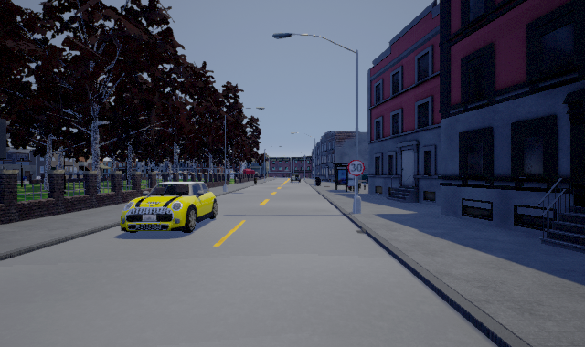
Example:

Fig.1 An image from the dataset

PASCAL VOC FORMAT -XML file for annotations of the Fig.1

<annotation>
<folder>_rgb</folder>
<filename>Town02_002160.png</filename>
<path>/home/daniel/CARLA_0.9.5/PythonAPI/examples/Dataset/Town02_40_vehicles/_rgb/002160.png</path>
<source>
<database>Unknown</database>
</source>
<size>
<width>640</width>
<height>380</height>
<depth>3</depth>
</size>
<segmented>0</segmented>
<object>
<name>vehicle</name>
<pose>Unspecified</pose>
<truncated>0</truncated>
<difficult>0</difficult>
<bndbox>
<xmin>131</xmin>
<ymin>199</ymin>
<xmax>238</xmax>
<ymax>255</ymax>
</bndbox>
</object>
<object>
<name>traffic_sign</name>
<pose>Unspecified</pose>
<truncated>0</truncated>
<difficult>0</difficult>
<bndbox>
<xmin>380</xmin>
<ymin>175</ymin>
<xmax>399</xmax>
<ymax>193</ymax>
</bndbox>
</object>
<object>
<name>vehicle</name>
<pose>Unspecified</pose>
<truncated>0</truncated>
<difficult>0</difficult>
<bndbox>
<xmin>318</xmin>
<ymin>188</ymin>
<xmax>328</xmax>
<ymax>201</ymax>
</bndbox>
</object>
</annotation>

PYTHON CODE FOR ANNOTATING THE IMAGE FROM XML FILE:
from PIL import Image, ImageDraw
import xml.etree.ElementTree as ET

sample_image = Image.open('/home/aashiqueluqman/vista/Carla-Object-Detection-Dataset-master/train/Town02_002160.png')

tree = ET.parse('/home/aashiqueluqman/vista/Carla-Object-Detection-Dataset-master/train/Town02_002160.xml')
root = tree.getroot()

bbox_coordinates = []
for member in root.findall('object'):
class_name = member[0].text # class name

# bbox coordinates
xmin = int(member[4][0].text)
ymin = int(member[4][1].text)
xmax = int(member[4][2].text)
ymax = int(member[4][3].text)
# store data in list
bbox_coordinates.append([class_name, xmin, ymin, xmax, ymax])

sample_image_annotated = sample_image.copy()

img_bbox = ImageDraw.Draw(sample_image_annotated)

for bbox in bbox_coordinates:
print(bbox)
img_bbox.rectangle(bbox[1:], outline="red")
img_bbox.text((bbox[3],bbox[4]),str(bbox[0]),align='right')

sample_image_annotated.show()
sample_image_annotated.save('Town02_002160an.png','PNG')

ANNOTATED IMAGE:
